### Task description

Given an integer input N between decimal values 2 and 100, create a two-dimensional table of N x N size.

Table columns should be marked with capital letters of the English alphabet, much like in an Excel or Google Spreadsheet: letter “A” through “Z”, then “AA”, “AB”, etc. Table rows should be marked with the ordinal value representing the number of row, starting from 1.

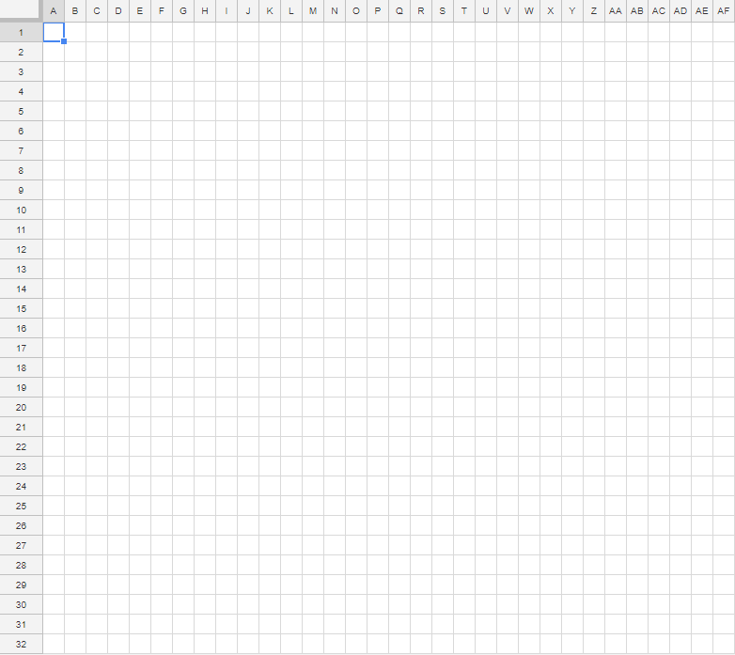

Figure 1. Visual representation of the table for N=32

A table cell should be filled with a single solid color representing a linear gradient color value calculated as follows:

* The top left cell has a fixed RGB value of (255, 255, 255).
* The bottom right cell has a fixed RGB value of (255, 0, 0).
* Any other cell color should be calculated as a linear gradient value based on the cell’s distance from the top left and the bottom right anchor cells.

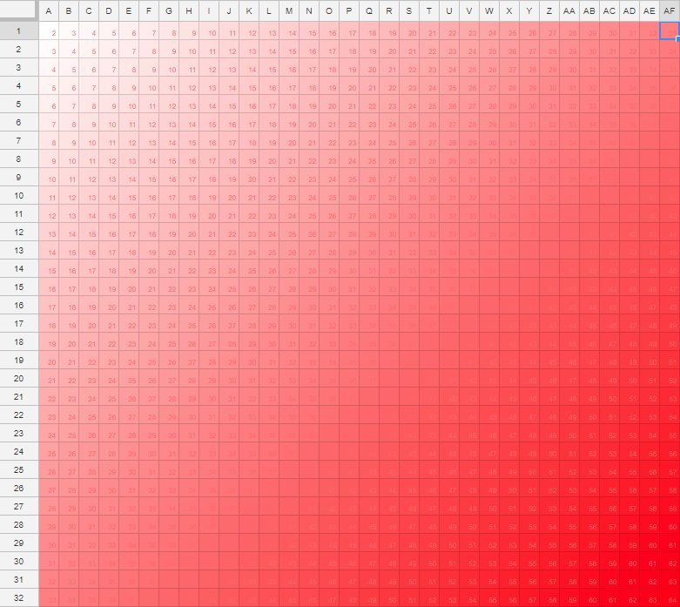

Figure 2. The resulting table filled with the calculated colors (ignore the numbers)

The user should be able to enter the N value into an input field, and create the corresponding table by pressing a button. N should be validated to match the following conditions: N is integer, 2 <= N <= 100.

The resulting table should reasonably fit the screen - if the screen is too small to display the characters in column or row headers, scrolling is permitted.

### Other requirements

The task shall be implemented with Dart (version >= 2.0.0) programming language and Angular Dart (version >= 5.0.0) framework, as a web project.

The program shall behave identically in all modern browsers (last two versions of Chrome, Firefox and Safari + latest Edge).

Submitted code should adhere to Dart and Angular best practices and style guides.

The solution should be submitted as a public Github repository url.